Name: kimheeseo Date: 2022.09.12

**Article Annotation Practice**

Preparing for an Annotated Bibliography

|  |
| --- |
| Instructions (설명) |

1. *Insert information from one research article you will read in the* ***Article Information*** *table.*
2. *Answer the annotation questions in the* ***Before Reading*** *and* ***After Skimming*** *tables.*
3. *In* ***Article Notes and Highlighting****, copy and paste annotations you’ve made directly on the article. (and delete the example)*

|  |  |
| --- | --- |
| *Article Information* | |
| Title | Learned Decimation for Neural Belief Propagation Decoders : Invited Paper |
| Author (s) | Andreas Buchberger, Christian Häger, Henry D. Pfister, Laurent Schmalen, Alexandre Graell i Amat |
| Journal Title | ICASSP 2021 - 2021 IEEE International Conference on Acoustics, Speech and Signal Processing (ICASSP) |
| Year of Publishing | 06-11 June 2021 |
| Volume/Issue |  |
| Pages | p.5 |
| Keywords / Search Terms | LDPC, NBP(neural belief propagation), decimation |

|  |
| --- |
| Article Notes (a.k.a. Annotation) |

|  |  |
| --- | --- |
| **Before Reading the Article** | |
| Question | Answer |
| What key information are you hoping to get from this paper?  Or  What questions are you expecting to be answered by reading this paper? | Recent research trend is to use deep learning in many research field. Therefore, there is a question of how to use the neural network architecture. What algorithms or deep neural network method(architecture) do researcher use? |
|  |  |
| Which section of the paper is the best place to find that information (or answer those questions)? | ‘section 3. Decimated neural belief propagation decoder’ deals with the neural network(NN), an important part of the paper. Total decoding process consists of a two steps, ‘List-based Decimation Stage’ and ‘Learned Decimation Stage’, and each stage process and order are described. |
|  |  |
| How does this paper relate to other research/articles in the field?  *(Is the paper a foundation paper that explains basic methods that are now used by all researchers, is the paper using a novel technique or perspective from prior research?*) | Recent research trend is using deep learning. (in the paper) In particular, deep learning is used to improve performance and complexity. The main goal of this paper is to improve complexity issue, so I think it will be helpful for future research.  This paper is using a novel technique. |

|  |  |
| --- | --- |
| **After skimming the article**  ( reading abstract, figures, reading the beginning and/or end of key paragraphs/section ) | |
| Question | Answer |
| What info in this article is still useful to you? | My interest subject is channel coding with deep learning. So, It was helpful because it was one of the various methods of deep learning.  (In other paper) Many researchers focused on check node updates,  but it is characterized by focusing on variable nodes in this paper. It is interesting part of this paper. |
|  |  |
| What is the purpose or aim of this study(the research done in this paper)? | adjust tradeoff of performance and complexity.  Reducing complexity compared to previous studies (paper or research), and making similar performance as possible, i.e. adjusting tradeoff appropriately. |
|  |  |
| What is/are the main/key outcomes (results/conclusions)? | adjust tradeoff of performance and complexity. |
|  |  |
| What was/were important aspect(s) of their procedure or methods? | Since researcher don't know sign, researcher set it to +- infinity as a method for decimation and used 'learned decimation stage' to use NN(neural network).  In particular, the parameters were optimized through deep learning. However, limitation thing is that It didn't mention what parameter is specifically, but I think it's weight.  And it had other limitation thing that there was no standard for how many decimation times(number) each of the two stages. |
|  |  |
| Were there any limitations of the study? What were those limitations? *(perspectives the research didn’t cover, missing or unclear information, . . .)* | ‘Pruning neural belief propagation decoders’ is a paper that studies similar methods.  The performance was compared with 'previous paper', a similar study. But the performance did not seem to be compared under the same conditions(situation). |

|  |
| --- |
| Article Notes and Highlighting |

*In the empty space below, input an image of one page (of a hand annotated) or screen capture (of a digitally annotated) the journal article.*

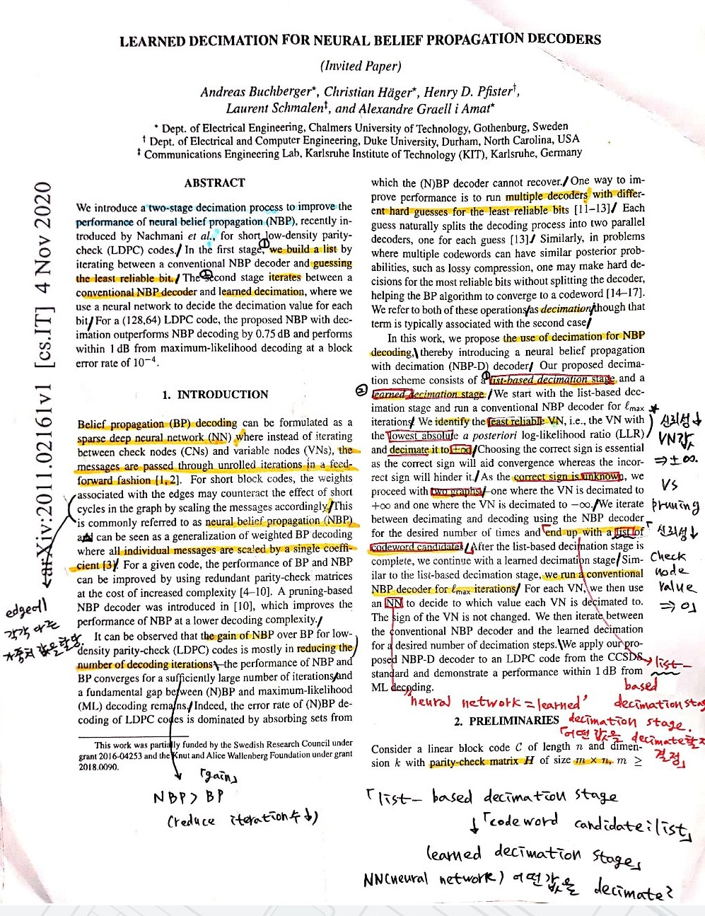

Highlight : before watching video.

Red box : after watching video.

|  |
| --- |
| Bibliographic Management Tools |

After deleting the example image below, take a screen capture of a list (at least 3 research papers) of articles you are reading or have read in one of the softwares (your preferred software choice) to organize your bibliography.

